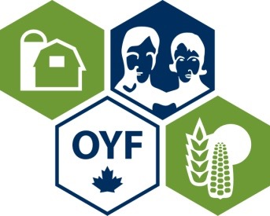

Here’s your chance to recognize someone with the title of Ontario’s Outstanding Young Farmer. This award will be presented at the OYF Regional Event.

We are seeking people who contribute to the community, who seek new opportunities, and who generally are assets to Ontario’s agri-food industry.

Anyone can nominate a young farmer/farm couple/farm partnership for the award. The eligibility requirements are simply:
- Must be between the ages of 18 and 39
- Must have an ownership stake in their farm
- Must derive a minimum of 2/3 of their income from their farm

The process is as follows:
- Nominations are to be submitted by January 31st.
- Nominees are contacted and asked to complete a detailed application form.
- A preliminary judging committee consisting of OOYF Alumni reviews the submitted application forms and contacts the top candidates. Their decision is based upon items such as the nominee’s progress in their agricultural career; adoption of soil, water, and energy conservation practices; financial and management practices and contribution to the well-being of the community, province, and nation.
- The top candidates will participate in a 20 minute interview with 3 judges and is asked to prepare and deliver a 15 minute powerpoint presentation that depicts their farm. This takes place at the Regional Event, date to be determined. The winner will be announced at the conclusion of the event.
- The provincial winner will then compete in the National competition in November/December which is designed to recognize young farmers that exemplify excellence in their profession.

If you know an outstanding young farmer, please nominate them by completing the nomination form (next page).

More information about OYF can be found on the website: https://www.oyfcanada.com/language/en/regions/ontario/

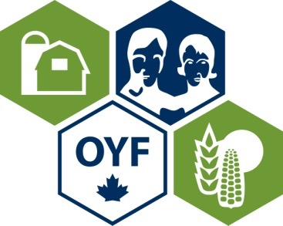
Ontario’s Outstanding Young Farmer
Nomination Form

Name(s) of Nominee(s):
Address of Nominee:
County:
Age(s):
Phone (include area code):
Webpage:
E-mail address:
Type of Operation:
Number of years involved in farming:
Percentage of income from farming:
Is the applicant aware of being nominated? | Yes No
Name and contact number of Nominator:
Organization (if applicable):
Signature

Nominations must be submitted by February 28th.
Please send to Cathy Bartolic,
OOYF Coordinator, 905-506-0371, ontarioOYF@gmail.com

