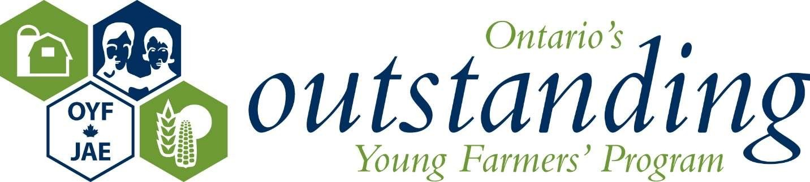

The Martin Streef Memorial Scholarship

The Martin Streef Memorial Scholarship is available to any full-time student in their final year of secondary school who is about to enter a post-secondary institution, or who is currently registered in a post-secondary institution leading to a degree or diploma. The application deadline for the OYF Memorial Scholarship is July 15th.

You will find the provincial application below and although it requests information pertaining to agriculture, it does not exclude applicants that are pursuing a non-agricultural degree. The committee thought that many students take degrees in such areas as business or science at a non-agricultural college or university before returning to an agricultural career. Applicants must somehow be related to an OOYF alumni. This means the applicant can be a son, daughter, nephew, niece, grandson or granddaughter, cousin etc. Please feel free to make copies of this application if more than one relative wants to apply.

The winner will be selected and notified by the end of August. The official announcement will take place in September. Please make any eligible applicants aware of this scholarship. We would like to thank the Streef Family for their generosity to the OYF program and we are most grateful for their support.

As proud farmers, we are honoured to be able to support, in Martin Streef’s memory, continuing education by offering a scholarship for post-secondary studies. The Martin Streef Memorial Scholarship of $500 will be awarded to one qualified individual who is pursuing post-secondary education in a course leading to a degree or diploma.

Eligibility
Any full-time student in their final year of secondary school and about to enter a post-secondary institution, or currently registered in a post-secondary institution, leading to a degree or diploma is eligible. This individual must be a family relation of an Ontario Outstanding Young Farmer Alumni. You may only win this scholarship once.

Martin Streef Memorial Scholarship Application

Name:

Address:

Phone:

Email:

Name of OYF alumni and relation:

Question: Why are you passionate about agriculture in Ontario? Please limit your essay to 750 words.

Please include:
- a copy of your current resume
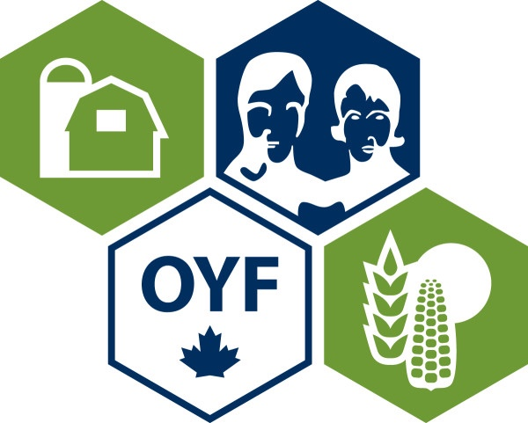
- a letter confirming your involvement in agricultural affairs (from a non-family member)
- a letter of character reference (from a non-family member)

The application deadline is July 15th. An OYF selection committee will judge the applications. The scholarship winner will be announced in August at the Celebration Event.

Please send your completed application to Cathy Bartolic, OOYF Coordinator:

Ontariooyf@gmail.com

OR

Mail to: OOYF, 3332 Stouffville Road, Stouffville, ON L4A 3X2

